Robot Framework Interview Questions:
1.Archeitecture

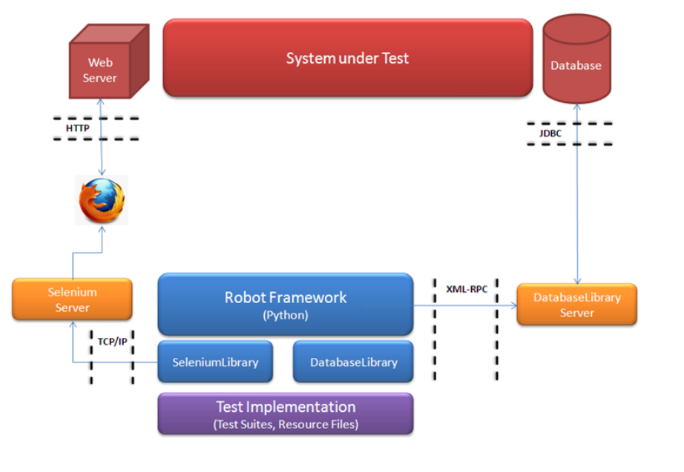
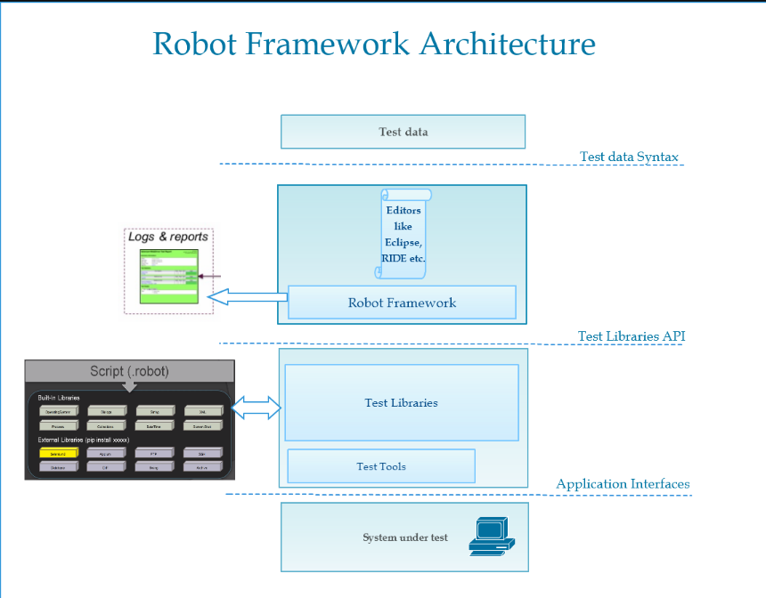

Folder Structure:

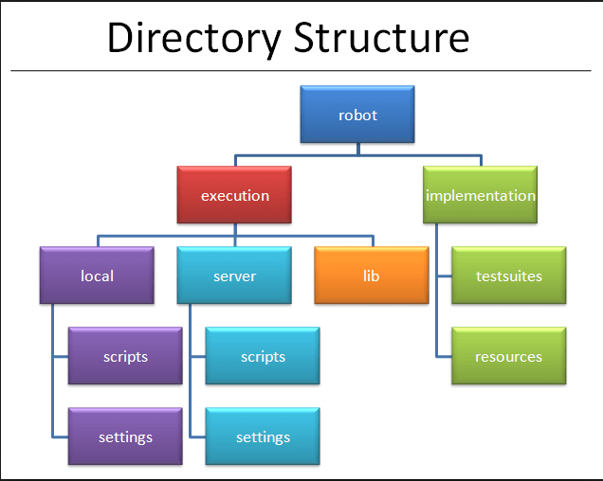

What is Robot Framework?
Robot framework consists of a set of tools, techniques and abstract rules; its job (besides allowing to write automated test cases) is simplifying the test automation process.
In practice, Robot is a modular test automation framework that has the capability to interact with 3rd party libraries and functions.

Robot Framework Vs. Selenium WebDriver
Robot framework or Selenium Webdriver? A question frequently asked in professional forums, the answer is pretty simple- “This question is irrelevant”, there is no sense in comparing the two.
Selenium is a library (some call it a webdriver) and Robot is a test automation framework that uses libraries. With Robot, you can run a variety of automated tests; Both UI element based and API tests, you can run a test with the help of the a math library and a test that validates if the element exists on the page, with the assistance of Selenium Webdriver.
With selenium, you can create UI based functional test cases, but in order to execute them, you’ll need a test automation runner or alternatively, an automation wrapper. There are several popular test runners available out there, for instance: MSTest, TestNG, Nunit, Junit etc.

Example:
Let’s take for example, mathematical libraries – we can use a simple “Add” function by transferring 2 parameters (1,2).
There is no need to implement this function, since it’s already has been implemented by somebody else and so it’s available for use. This call for a function with the parameters 1,2 will return the value 3.

Advantages:
Robot framework comes with a solid functionality and 3rd party libraries that others have already implemented; such as writing logs and reports, capturing screenshots, integration with continuous integration tools, support for KDT, simultaneous running and of course a connection to a variety of external libraries (e.g. the mathematical library we previously mentioned).
All these great features allow us to focus on our product testing, instead of investing a lot of time in reinventing the wheel.

2.How Many Type of Variables in RF?
Robot Framework has 3 types of variables
SCALAR -variable for URL and refer in Testcase
Syntax : ${VariableName}

LIST - LIST variable for username and password and refer in Testcase
Syntax : @{VariableName}

DICTIONARY -DICTIONARY variable for username and password and refer in Testcase
Syntax : &{VariableName}
ENVIRONMENT – We can not create a Environment Variables but we can GET and SET Environment Variables through IDE or RF
Notes:
1. If a non-existent variable is used in test-data, the keyword using it will fail
2. We can set variables from command line
3. Variables are case-insensitive
4. As best practice use uppercase variable names for global variables
And lowercase variable names for local variables

What are Keywords?
Keywords Actions that we perform on of our Test Cases
2 Types:
1.LIBRARY KEYWORDS : low level keywords
If you import any existing Library those Keywords are Library Keywords
Example : Open Browser ,Input Text , Close Browser …
2.USER KEYWORDS : high level keywords
custom keywords - combination of library keywords/actions
Note : We Search the Keywords by Pressing “F5”

1. What is Setup and TearDown
2. How to use

SETUP - keyword executed before running any lower level component/keyword
TEARDOWN - keyword executed after running any lower level component/keyword

Step 1 : Open RIDE
Step 2 : Create TestSuite Setup and Teardown and run it
Select TestSuite - Settings - Select Suit Setup - Click on Edit - It will give the Options for Suite SetUp
Note: Seprated by | symobol
Syntax: Keyword | Arguement

Log to Console | Test Suite Started
Similarly for Suite Teardown as well
Select Test Suite - Settings - Select Suit Setup - Click on Edit - It will give the Options for Suite SetUp

Note: Separated by | symbol
Syntax: Keyword | Argument
Log to Console | Test Suite Ended
Note: Similarly we can do it for Test Case Level as well

- How to create TAGS -Tags are used to classify/categorize test cases
Select Test Case - Settings - Tags Field - Enter Test Case
2. How to use tags during Test Execution
Select Run tab - There are 2 Options
1.Only Run tests these Tags
2.Skip tests with these Tags
3. How to use tags in Reports
Statics by Tags
4. How to create Dynamic Tags
Set Tags - To set the Multipule tags
Remove Tags - To Remove Tags
5. How to set TAGS from command line
Sanity, Smoke, Regression, Critical
Useful TIP
command line option : --settag

Step 1 : Goto cmd and cd to your robot framework project
Step 2 : syntax
robot -t TestName --settag=TagName TestSuite.robot

Note : If you want to give multipule Tags Seprated by |

example : Test4 | Sanity

